PROCESS FLOW DOCUMENT FOR SMR
LOGIX
SMR

1.ROLES
- User
- NOC
- Manager
- VP
- Admin
2.PROCESS FLOW
2.1 Login/Logout
Step | Action
1. | User can login using by their Username and Password.
2. | Create username as your own or with your email Id and password,plus there is a “Forget Password” in an option if you forgot your password and retrieve them.
3. | If user has forgotten password, selects link “Forget Password”
4a. | After link is selected, display window that asks user to enter their email ID. The data will be sending back to the system to validate.
4b. | System verifies given details:  - A password reset link will be sent to respective email  - Click the link in URL and reset the password
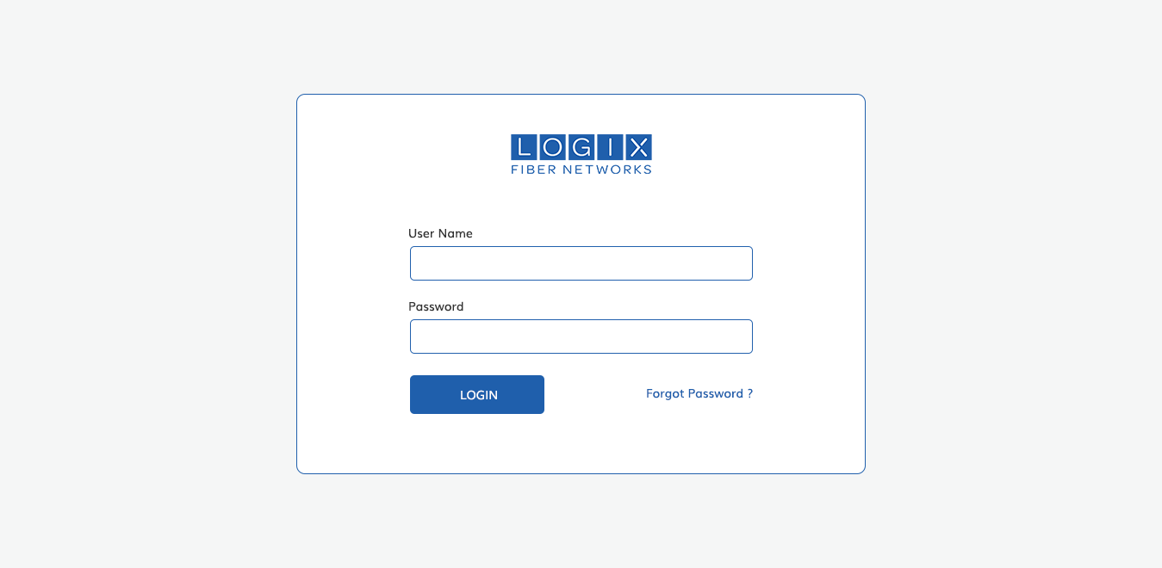

2.1.1. Dashboard
- After the successful login, the page navigate into Home page of dashboard
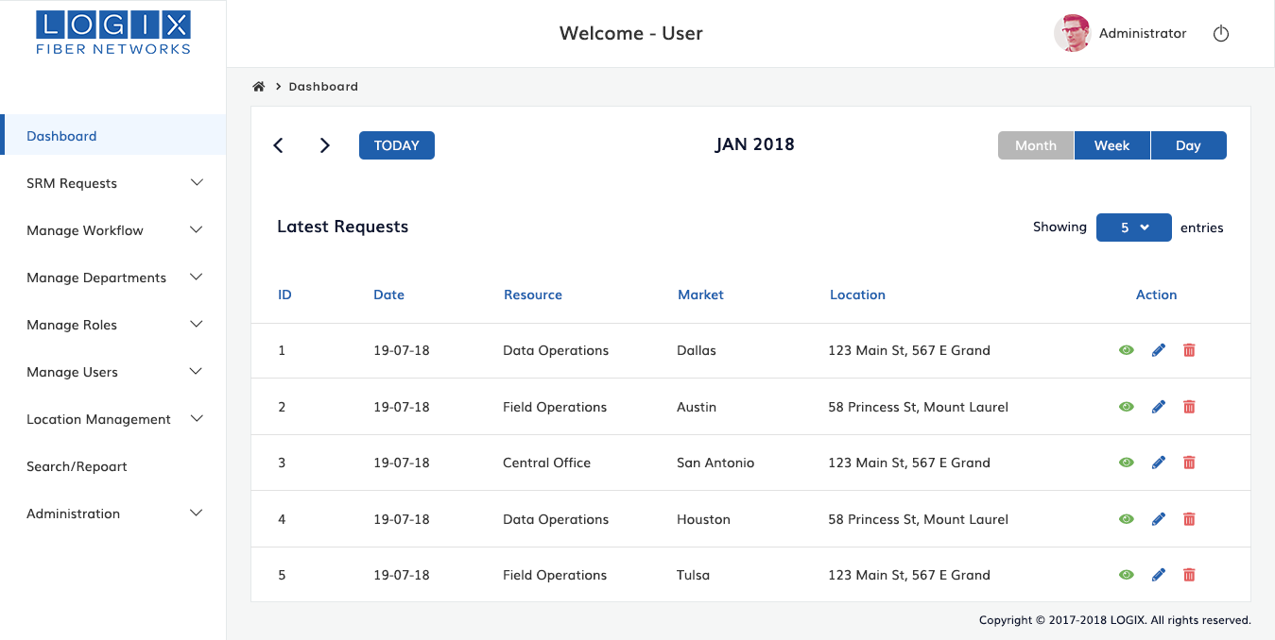

2.1.2 User Profile
This section offers to views the profile of logged users . If they need to change the theme, whether dark or light,can update it by Appearance section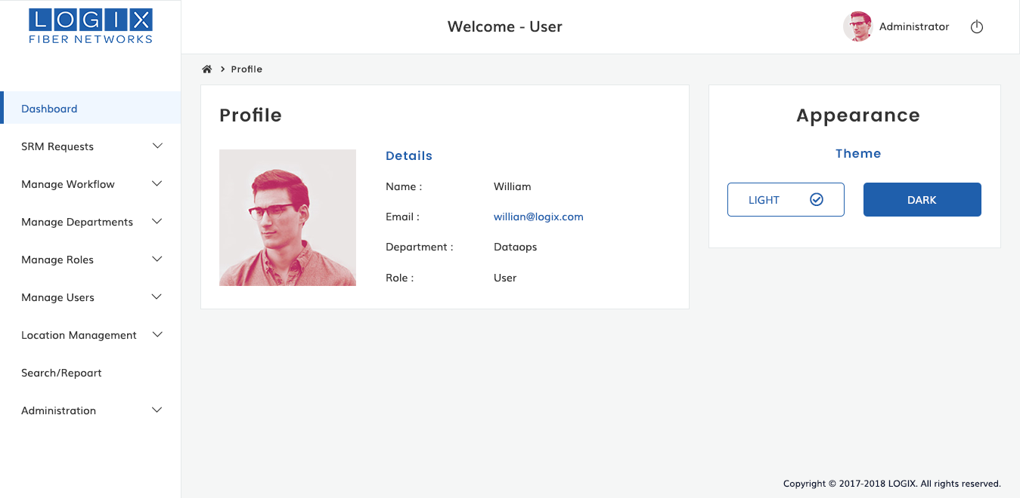

2.2 PUBLIC VIEW
There is a public calender view to mark the certain departmental and functional activities .
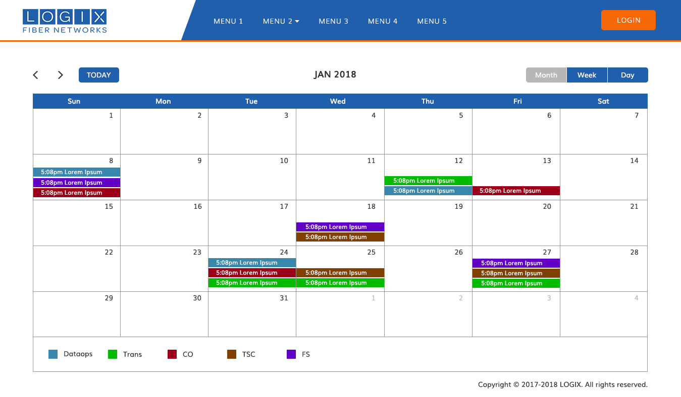
2.3 SMR REQUEST(SMR FORM)
2.3.1 Create Request
- This section will be used for create a new SMR request. Fill in the fields on the form, as appropriate.Send a request to superior(higher authority) and wait, until we get a feedback or approval from the concerned authorities.
- Once the Request is Published by the NOC, the date/time of the change event will be added to the calendar with basic information along with it being coded based on the department submitting the request

Create Request section contains the below fields,
- Name of Requestor
- Office Phone
- Department
- Cellphone
- Program/Project Name
Step | Action
1 | From the dashboard, navigate to SMR REQUESTS Click Create Request Menu
2 | After clicked, Create A Request Form will be displayed.Fill in the fields on the form, as appropriate.
3 | Name of the requestor field should be an auto.Enter the phone number of office
4 | Select and choose department from the provided list
5 | Enter the mobile number to the Cell Phone field
6 | Write down the name of project in the project field
7 | After filled all the field click and save button .Next proposed changes form will display.

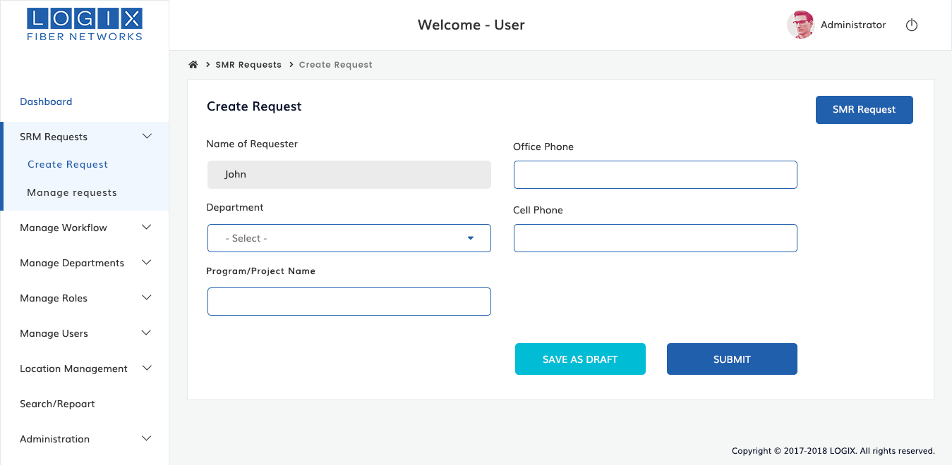

2.3.1.1 Proposed Changes:
After filled the request form ,they will send request to higher authority(superior) .The request form ,request number ,status of request data should be display on the top of section. Next concerned authority will fill the remaining fields and submit to their superior. In history section shows, users name and details how many users requested , to related this project .

Proposed Changes section contains the below fields,
- Location Of Work
- Contact Number
- Resources/Groups needed
- Type of Maintenance request
- File Upload
Step | Action
1 | Create request information will be shown on the top section (2.3.1 form data should be displayed)
2 | Next authority will Fill in the fields on the form, as appropriate.
3 | Select and choose the location of work from the provided list
4 | Enter the contact number
5 | Choose Resource or groups if you need to support with your work
6 | Write down the type of maintainance request
7 | If you have any attachment files you can upload through the file field and submit request button.Remove button to removed attached file
8 | After submit this form ,Submit SMR form will displayed

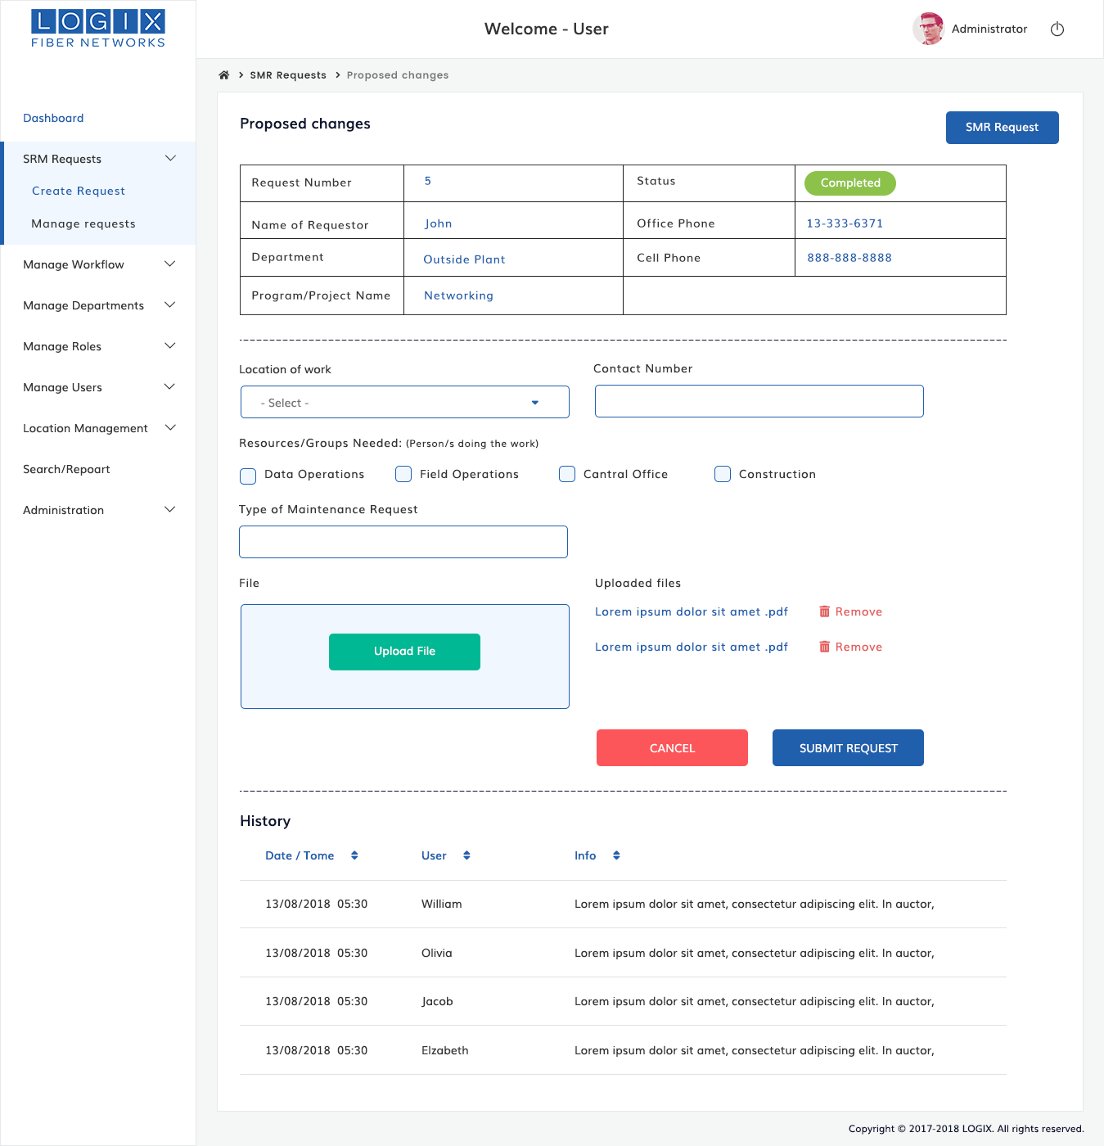

2.3.1.2 Submit SMR
Request form data and proposed changes form data will display in this section .Next superior (higher authority )will fill the remaining section on the form and send to superior(higher department) .

Submit SMR section contains the below fields,
- Date of proposed work
- Time of proposed work
- Work Requested
- File

Step | Action
1 | Request form data,status of request and proposed form data should display on the top of the section .
2 | Next higher authority member(Next concerned department) will fill in the remaining fields on the form , as appropriate.
3 | Write down the date when the work is gonna start.
4 | Enter the Actual time to finish the work in the time of proposed work field
5 | Briefly and thoroughly explain about the sought of issues of facing for the technician to rectify it clearly for a better use in the future to enter in the work requested field
6 | Write down the Expected time of service in Expected duration field. Upload the files using the file field .Remove button enable us to removed the attachement file. After filled all the information click submit request button.
7 | The Request form can be saved as a Draft as information is provided and not submitted until the user is finished with gathering all the information needed for the maintenance activity.

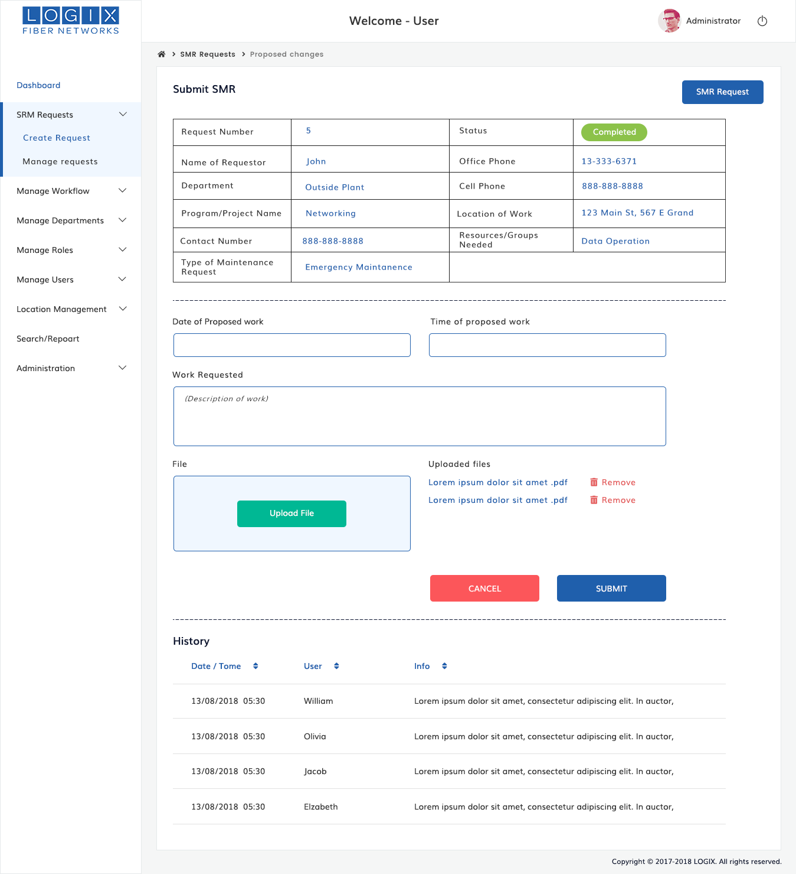

2.3.1.3 Review/Evaluate Customer Impacts
After submitted the SMR request form ,Next higher authority(concerned department) will fill on the form and send request to their superior get an approval for maintenance .
Review/Evaluate customer impacts section contains the below fields,
- Expected Duration of service Outage
- Approximate number of customers impacted
- Service impacted
- Estimated costs
Step | Action
1 | After submit SMR Submit form ,Review/Evaluate customer impacts form will be displayed .
2 | Previous entered request form,proposed form,submit SMR form data should view on this top section
3 | Higher Authority(concerned departments) will fill in the remaining field on the form,as appropriate and send to higher authority(higher department)
2 | Write down the Expected time of service in Expected duration field. After filled the information click submit request.
3 | The Request form can be saved as a Draft as information is provided and not submitted until it is finished with gathering all the information needed for the maintenance activity.

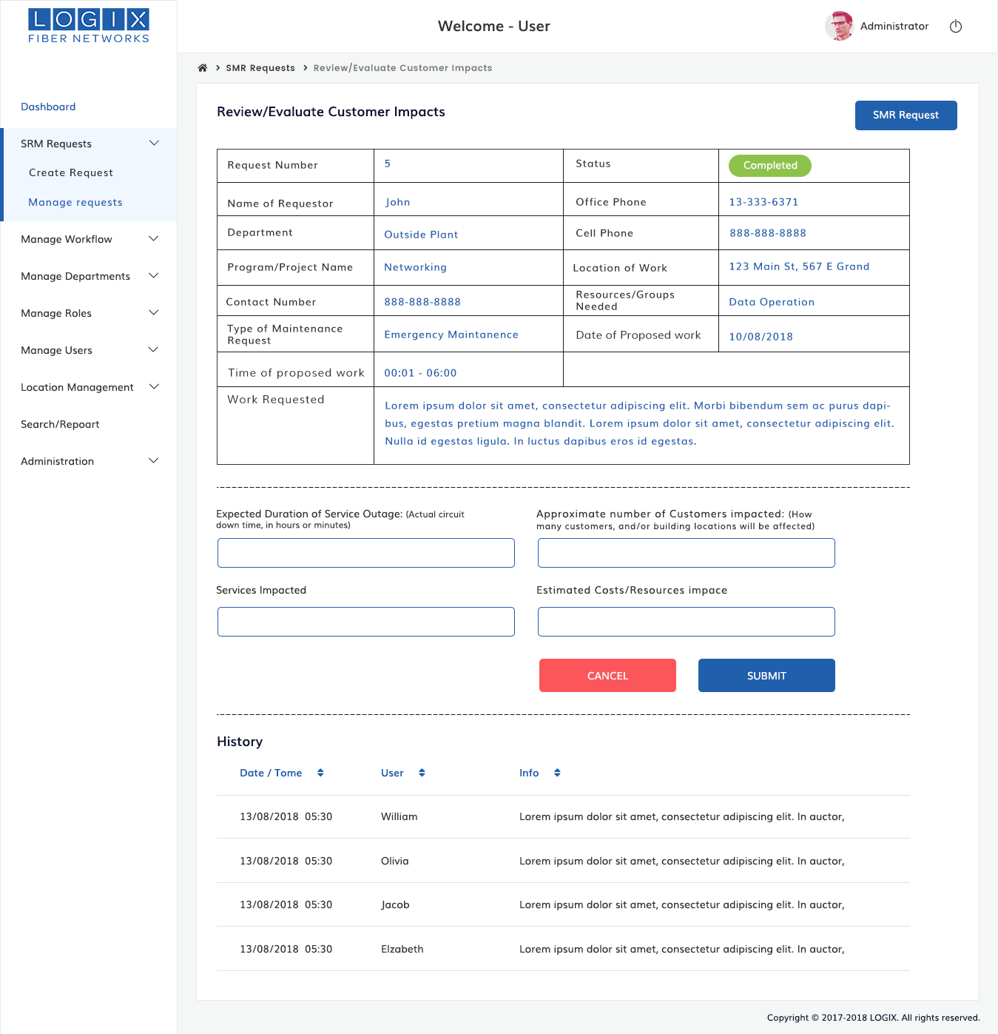
2.3.1.4 SMR Validation

SMR Validation section contains the below fields,
- Work Requested
- VP Approval Required

Step | Action
1 | After finished evaluate or review customer impacts form ,SMR validation Form will display here .
2 | Request form,proposed changes,SMR Submit ,Review form,these all the information will show on the top of the section.
3 | Higher authority member will fill in the field on the form ,as appropriate
2 | Briefly and thoroughly explain about the sought of issues of facing for the technician to rectify it clearly for a better use in the future to enter in the work requested field
3 | If need VP approval tick in the approval section
4 | Click Submit Button ,will send a request to higher department to get an approval.
5 | If you need to get an approval from VP,tick yes button of VP approval required field
6 | Related requested information will show on the history section
7 | After gathering all the information, will send request to his higher authority for get an approval, the higher authority should schedule the date for maintenance
8 | Once the request is approved. It will send to noc for confirmation. The request will show on the SMR Calendar and email notification will receive to the orginator

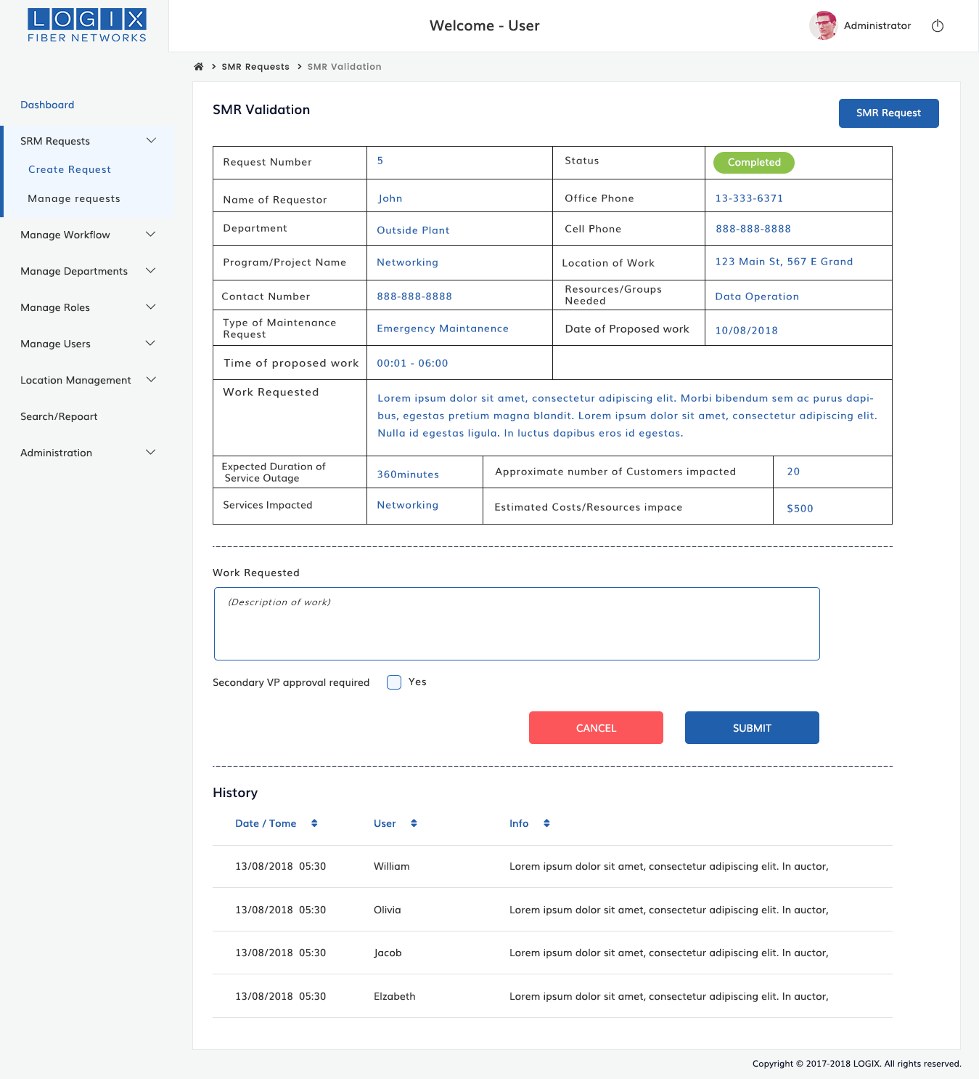

2.3.1.5 Re-analyze
Previous requested and entered the information will display here.If you want to change or update the data( proposed changes form and submit SMR form data) ,you can update the information through reanalyze form .Once you are done click submit request button. After gathering all the information, will send request to his higher authority for get an approval, the higher authority should schedule the date for maintenance.
Once the request is approved. It will send to NOC for confirmation. The request will show on the SMR Calendar and email notification will receive to the orginator.
Re-analyze section contains the below fields,
- Location of Work
- Contact Number
- Resources
- Type of maintenance
- Date of proposed work
- Time of proposed work
- Work Requested
- File

Step | Action
1 | Request form,proposed changes,SMR request form,evaluate form ,these all form information will display on this section
2 | Review again what you requested ,If you need to update the information ,you can update through this form.
7 | After changes has done click submit request button to send request to higher authority.
8 | Once the request is approved. It will send to NOC for confirmation. The request will show on the SMR Calendar and email notification will receive to the orginator

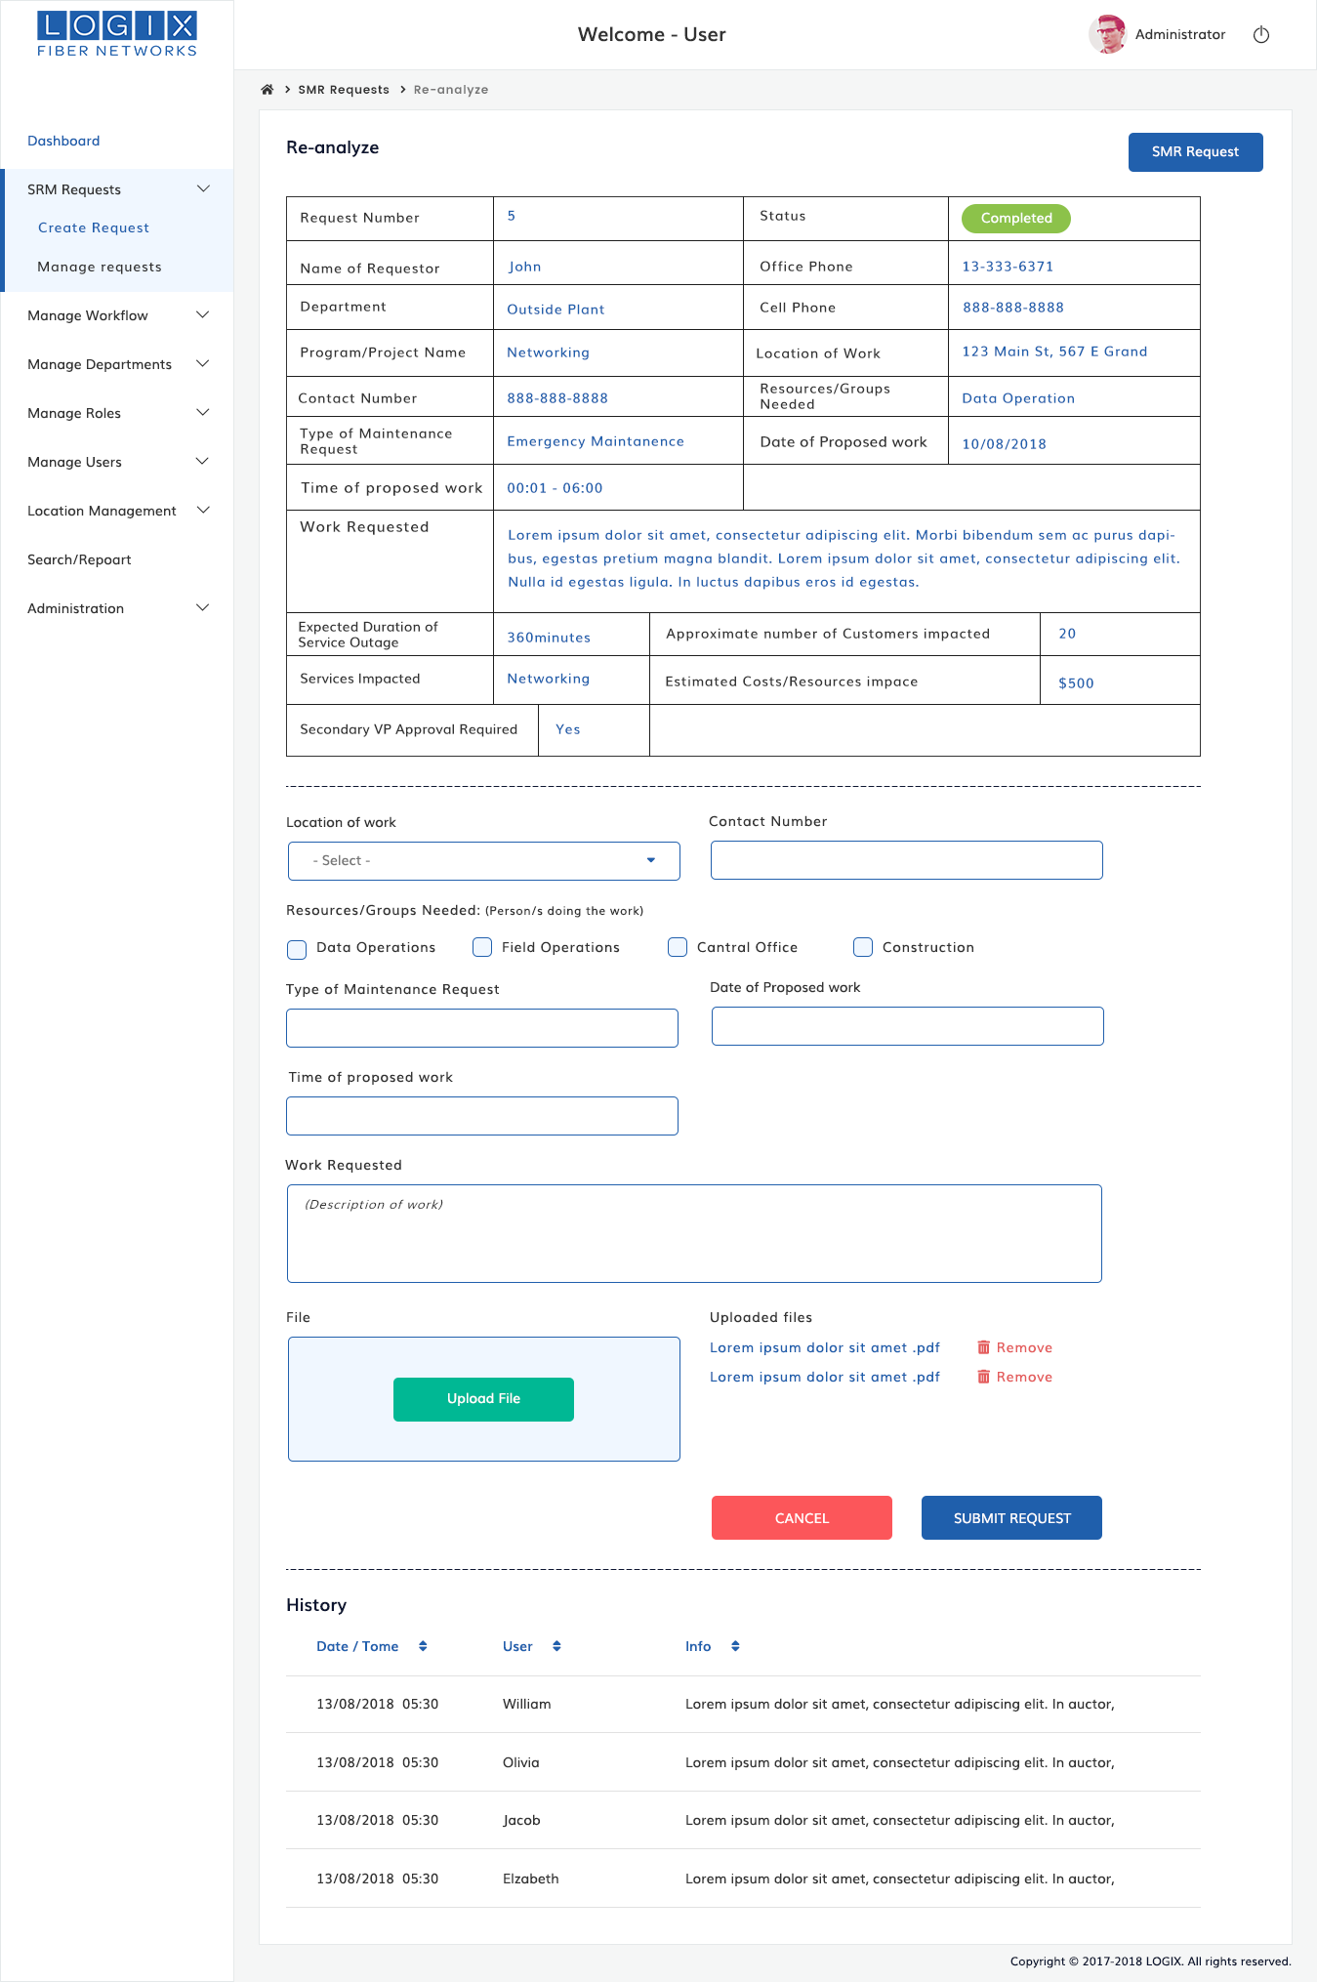

2.3.2 Manage Request
List of all Requests as shown in the below, Action column offeres to view,update and delete the request.View icon enable us to viewed the information ,Edit icon enable us to edit the fields as per our needs and once you are done save it.Delete icon is used to remove or delete the unwanted requests.
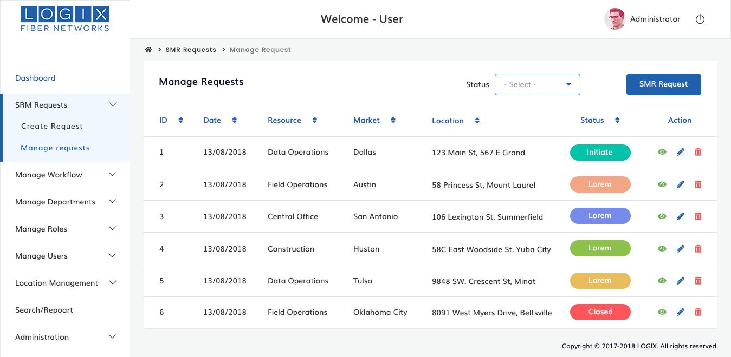

2.4 MANAGE WORK FLOW
This section offers you to know the flow of current status of the each project or program.
2.4.1 Work Flow:
This sections is used ,able to know the current status of project and activities .Action column offeres to manage the activities update and delete all information.manage activities icon enable us to viewed the activities ,Update icon enable us to update the fields as per our needs and once you are done save it.Delete icon is used to remove or delete the unwanted information.

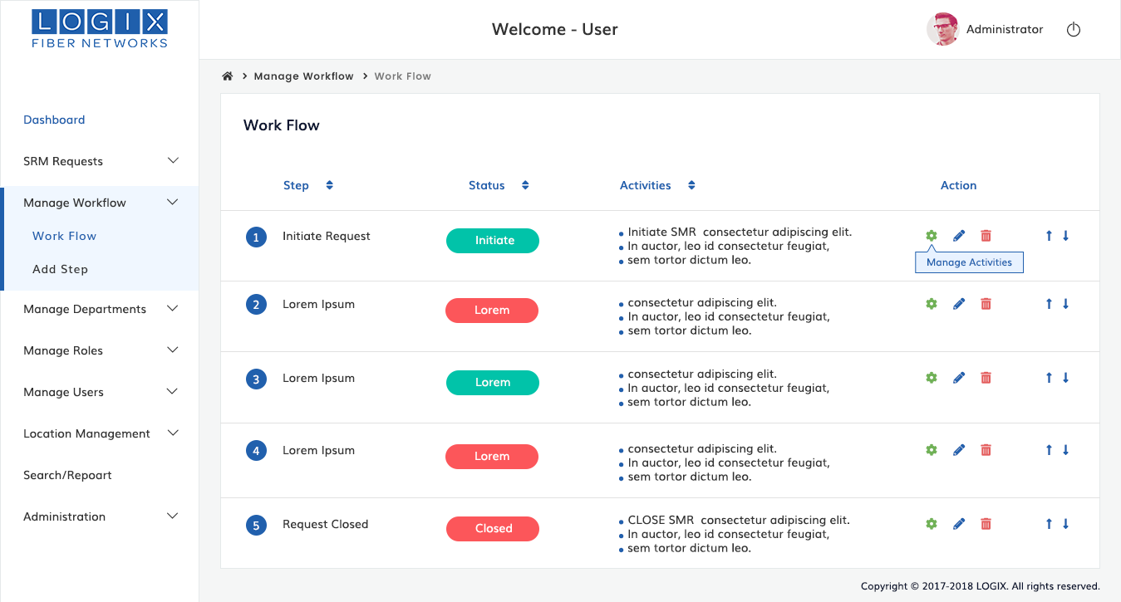

2.4.2 Add Step:

Add Step section contains the fields,
- Step Name
- Status Name
- Select Activities
- Capable Users
- Notifications
Step | Action
1 | In Manage WorkFlow menu from the dashboard Click Add Step sub menu which present below
2 | Write down the Name of step in the step field
3 | Choose and select Activities from the provided list
4 | Choose the capable users from the list as your needs
5 | Tick notification from the below notification check list and save it
6 | If you want to add more steps, click an ADD MORE button and fill in the fields as appropriate.
7 | All work flow list shown on the Work Flow menu section under the submenu of Manage Workflow

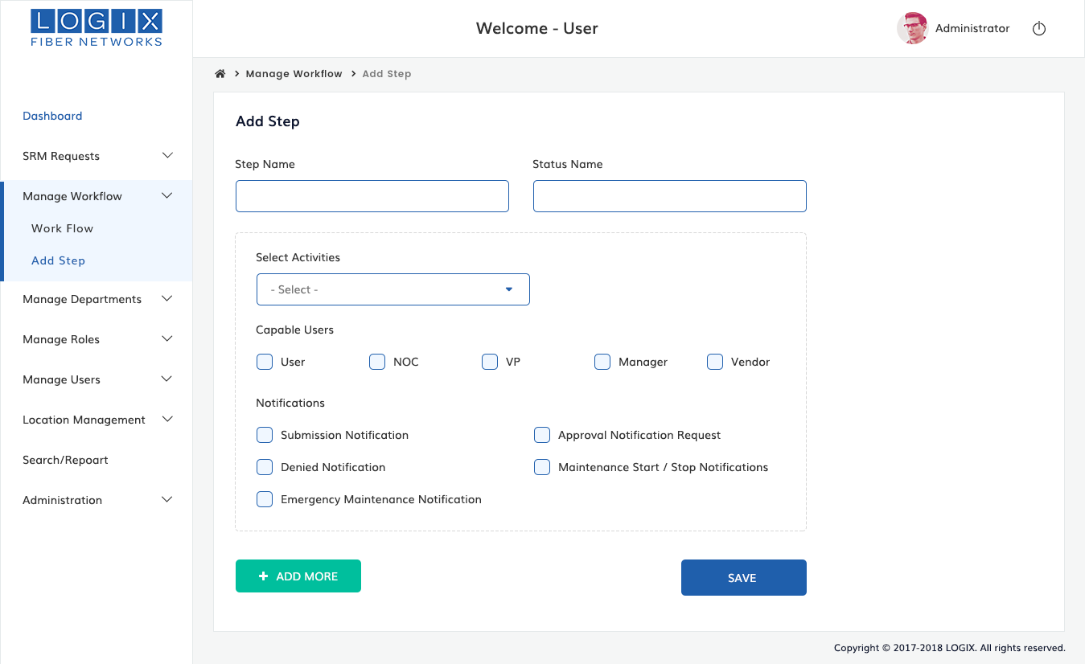

2.5 Manage Departments
To Setup & Manage Departments, Follow These Steps:
2.5.1 Create Department
Create any department as per need.To create a new department, Enter the name of the department and descriptions.Click on the 'Save ' button or press the Enter key on the keyboard. The new department will be created and shown in the list of departments. Now you can add members to the newly created department.

Create Department sections contains the below fields,
- Name
- Description
Step | Action
1 | Choose “Manage Departments” menu from the dashboard
2 | Click “Create Department” menu under the submenu of Manage Department
3 | Create the new department name in the name field as your needs
4 | Add Descriptions to the department field and save it
5 | After created the Department ,the new department list will be shown in the departments list section

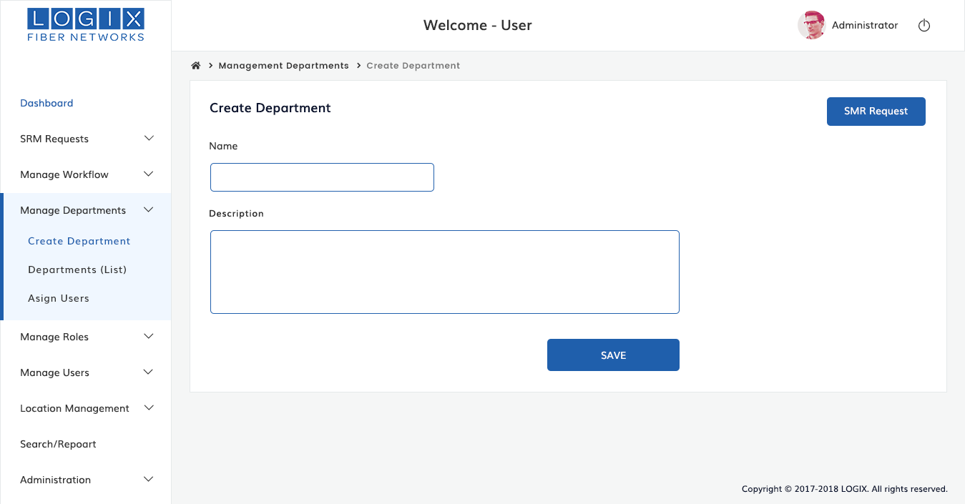
2.5.2 Departments(List)
List of the departments and view it.There will be an Action section in the department list table .When click an edit icon you can update the information as your need .When click delete button, the selected information will be deleted.
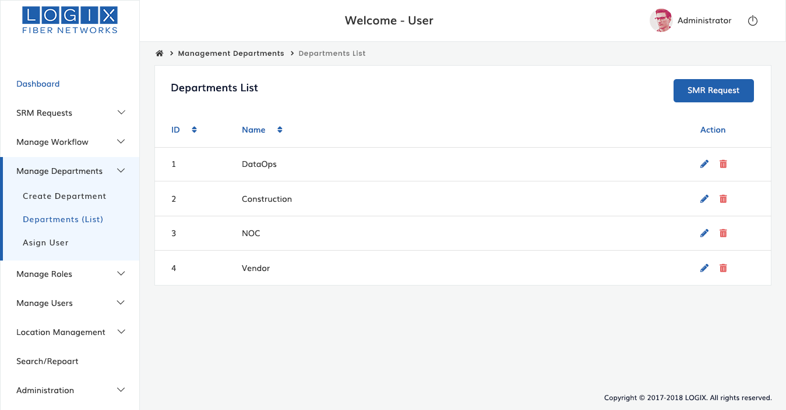

2.5.3 Assign Users
This section is used to specifies single or multiple users can assign or add to your department.
Assign Users
Assign users section contains the below fields,
- Select Department
- Users
Step | Action
1 | Choose MANAGE DEPARTMENTS from dashboard Click Assign Users menu
2 | Select a department name from the select department drop down list
3 | Then click those users are in need to add your department, you could add single or multiple users from the drop down list
4 | After added users to department then click and save button

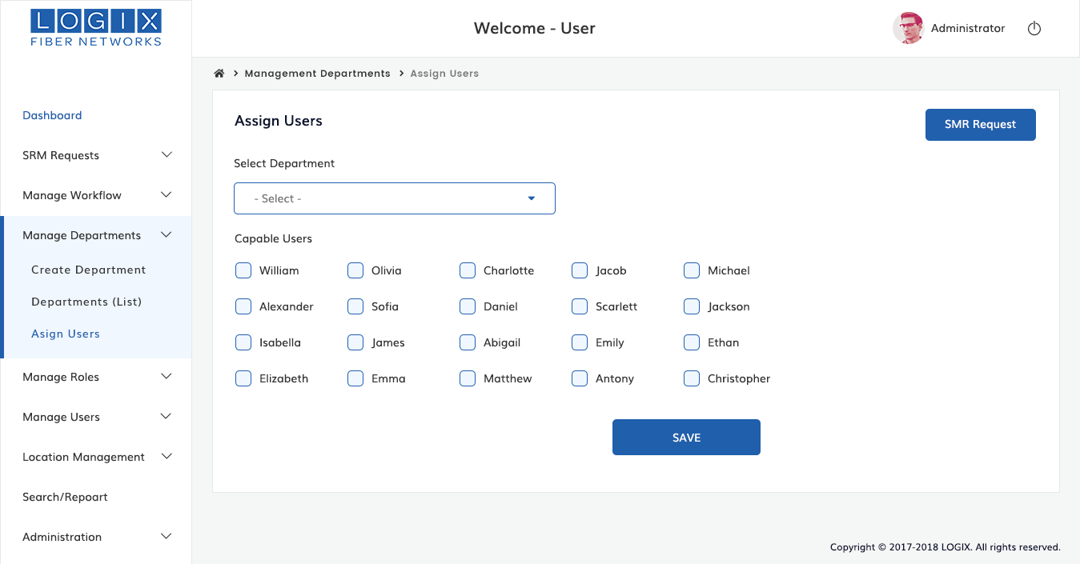

2.6 MANAGE ROLES
Manage roles is used to create ,remove and assign any roles to users.
2.6.1 Create Role
Able to create ,remove and assign roles to users as per needs.
Create Role section contains the below list,
- Role name
- Description
- Abilities
Step | Action
1 | Choose MANAGE ROLES from dashboard Click Create Role menu  Which present below
2 | To create a role ,Enter the name of role ,add description about the role , either can choose single or multiple abilities from it and save
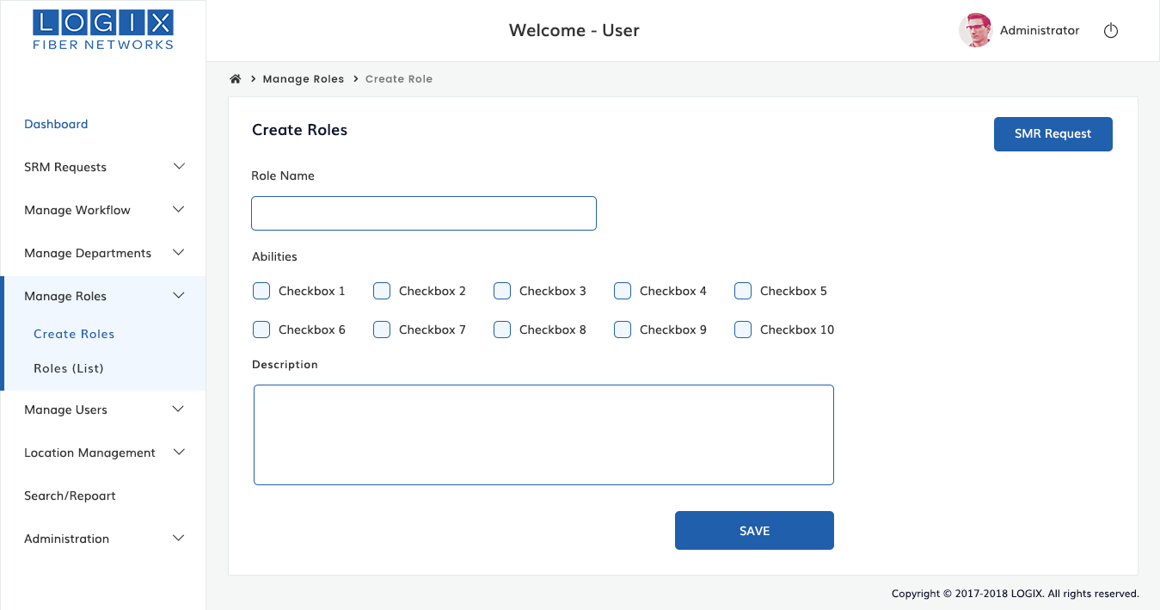

2.6.2 Roles(List)
List of Roles and view it,
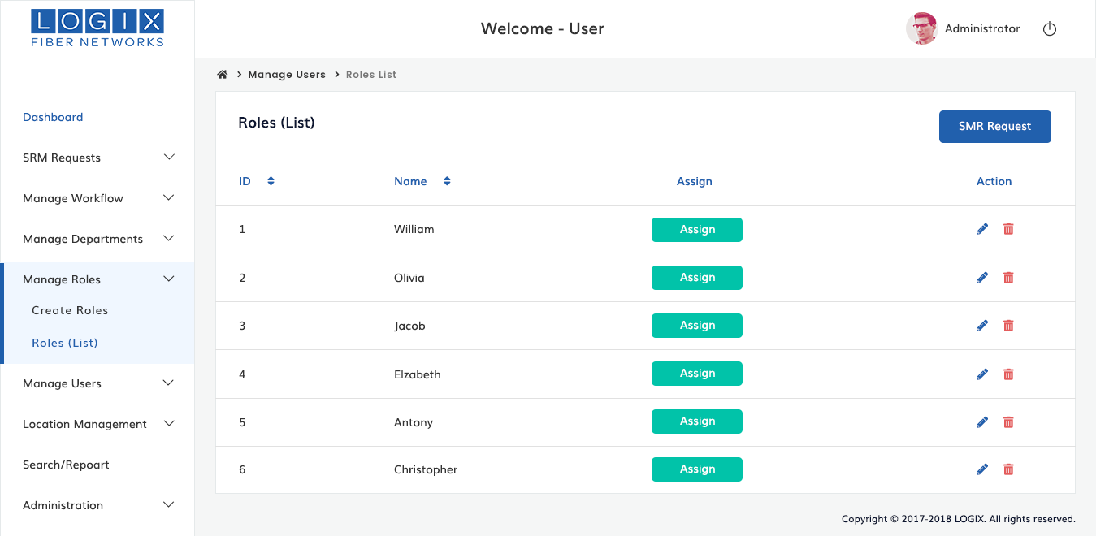
If let us click assign button, one popup will display we will get multiple users and choose as per our need.Then save it. Roles will be assigned to chosen users

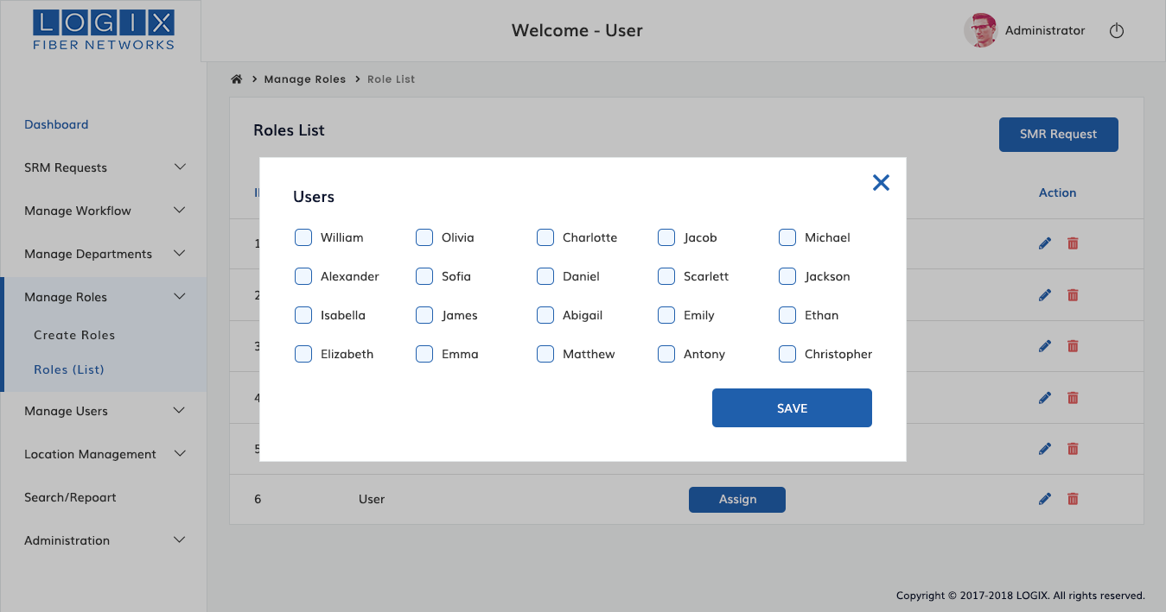
When click delete icon , popup will display “Are you sure want to delete this list” ,if click yes the the data will be deleted.
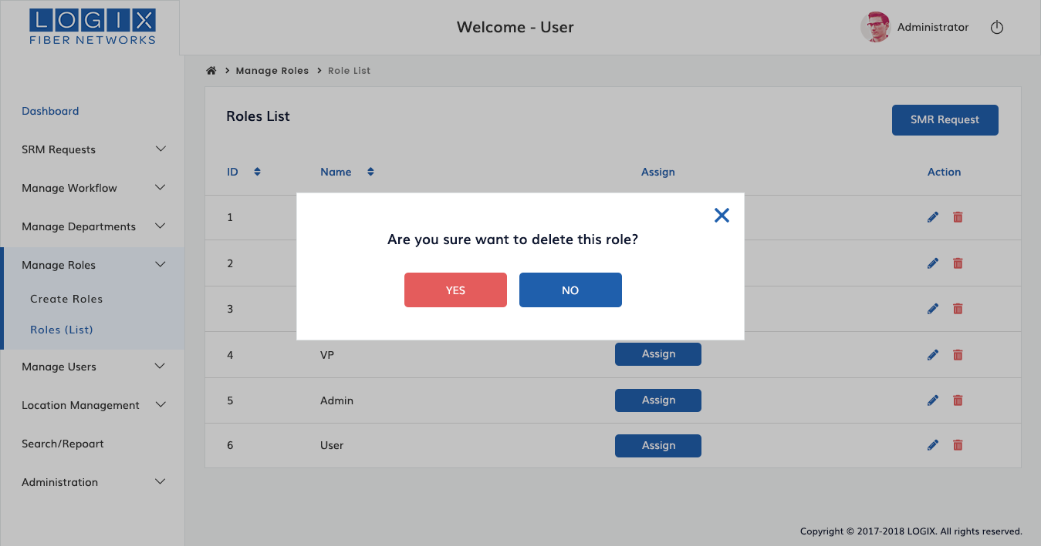

2.7 MANAGE USERS
Manage users is to create or add new users or update users or to delete users from the department
2.7.1 Create Users
If you want to add users to the department, you need to create a department first, and then add the user afterwards.To create a new user , Select the "Create User" from the menu in the left side.Enter the name ,Email,select a particular department name and role from the role dropdown list and also click option if you do not receive Email Notifications and save it .
Create users sections contains the below list of fields,
- Name
- Email
- Department
- Role
Step | Action
1 | Create a user name in the name field
2 | Enter the Email Address
3 | Select the department name from drop down list you want to add the user
4 | Select a role from the dropdown list .
5 | Then click do not notify checkbox otherwise notification will send via respective email
6 | After completed ,click save button field
7 | New users list will shown in the users list section

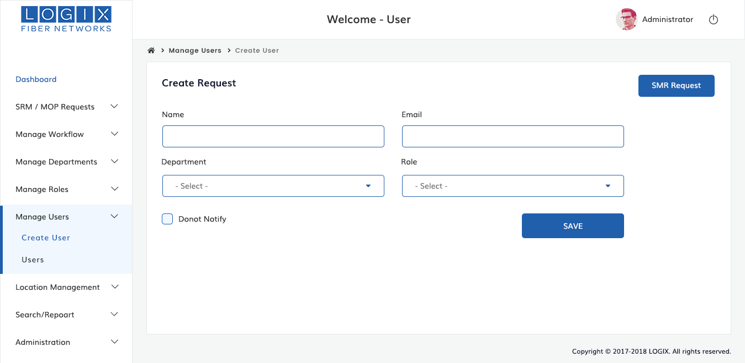

2.7.2 Users(List)
List of Users as shown in the below, Action column offeres to edit and delete information.Edit icon enable us to edit the fields as per our needs and once you are done save it.Delete icon is used to remove or delete the unwanted fields or data
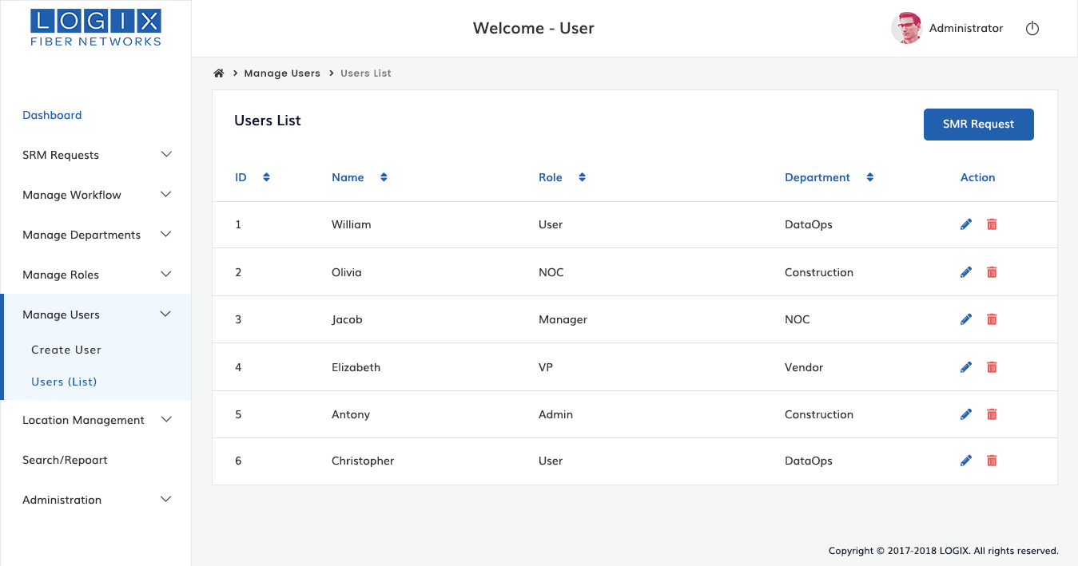

2.8 LOCATIONS MANAGEMENT
Location management is to find out the specify location of the device .After find out the request will be send to the Authority.
2.8.1 Create Market
Create a new market (city) as per your need,This market field will help to ways of finding impacted device of particular city. To create a market, writedown the name of market,Description about market and save it.

Create Market section contains the below fields,
- Create market
- Decription
Step | Action
1 | Write down the name of market in the market field (Eg:Dallas,Tulsa)
2 | Add description for the market and save it
3 | If needed, repeat steps to add multiple markets

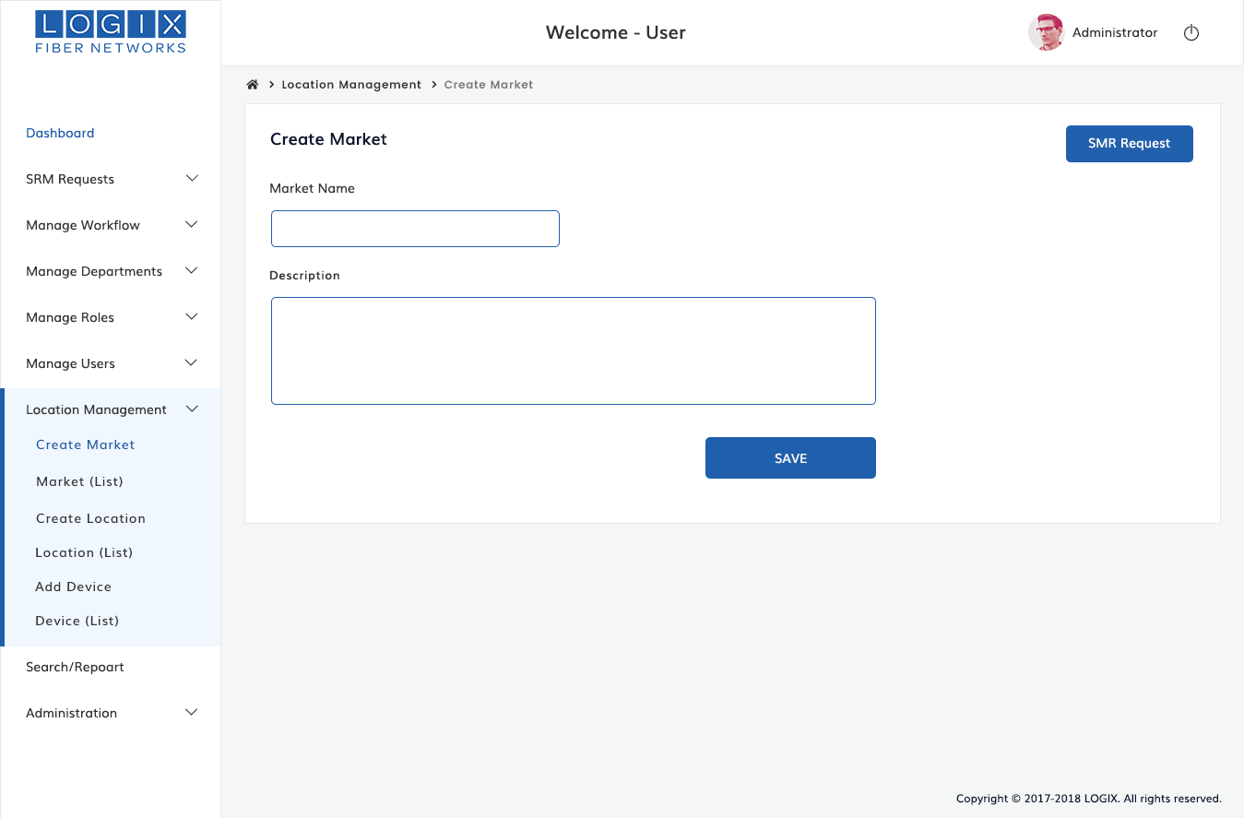
2.8.2 Markets(List)
List of markets and view it( Make list of market as wire firm).
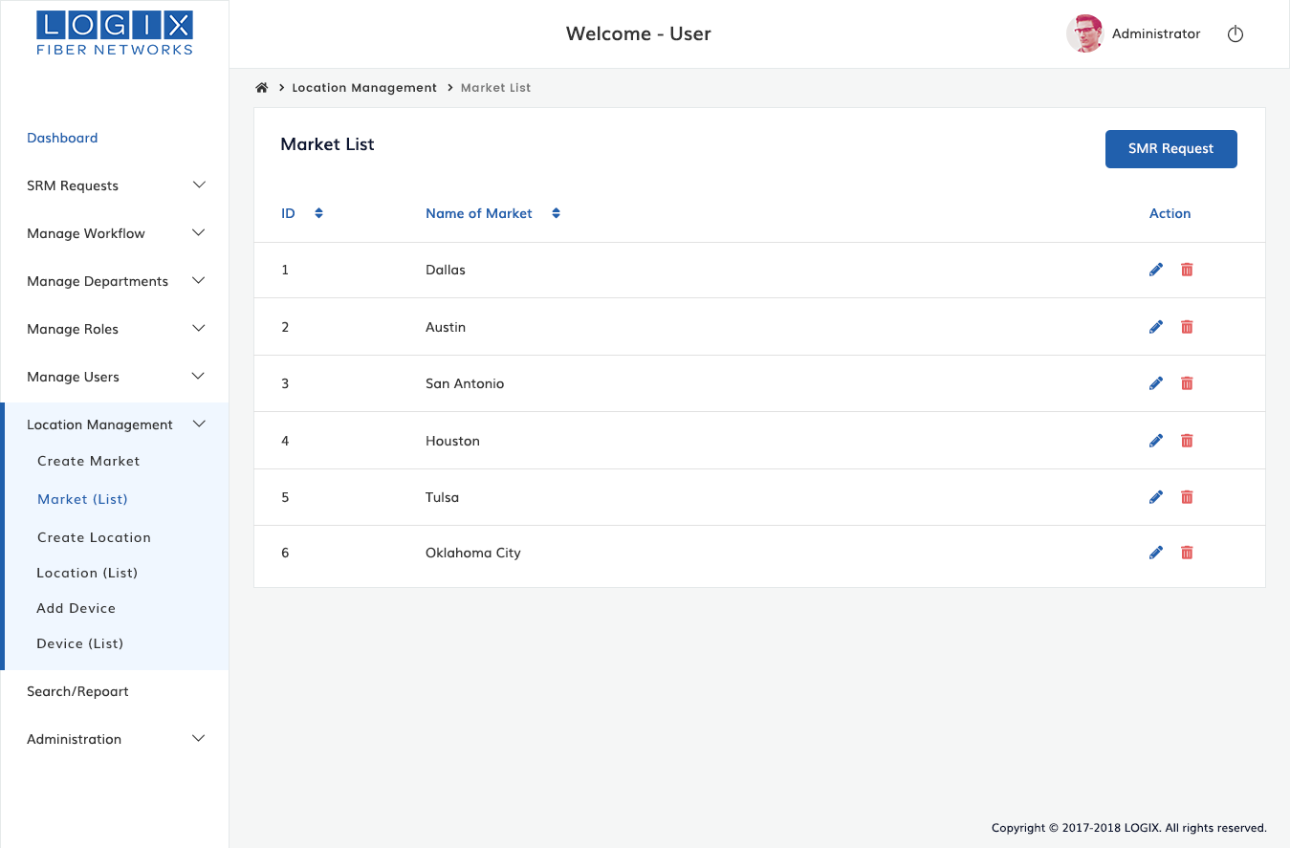

2.8.3 Create Location
Create Location section contains the below fields,
- Market
- Location
- Description
Step | Action
1 | Choose Location Management Menu from the dashboard click the create Location which is present below
2 | Select Market Name(city) from the Market name dropdown list(Eg:Dallas,Tulsa, etc)
2 | Type location of particular Market(city)
3 | Add Description if need and save it

Create any location for the market as per need .To create a location ,choose a market name from the provided list. Then write down the location of location field (Eg: 123 main st,567 E Grand), add description about location in the description section and click save button.

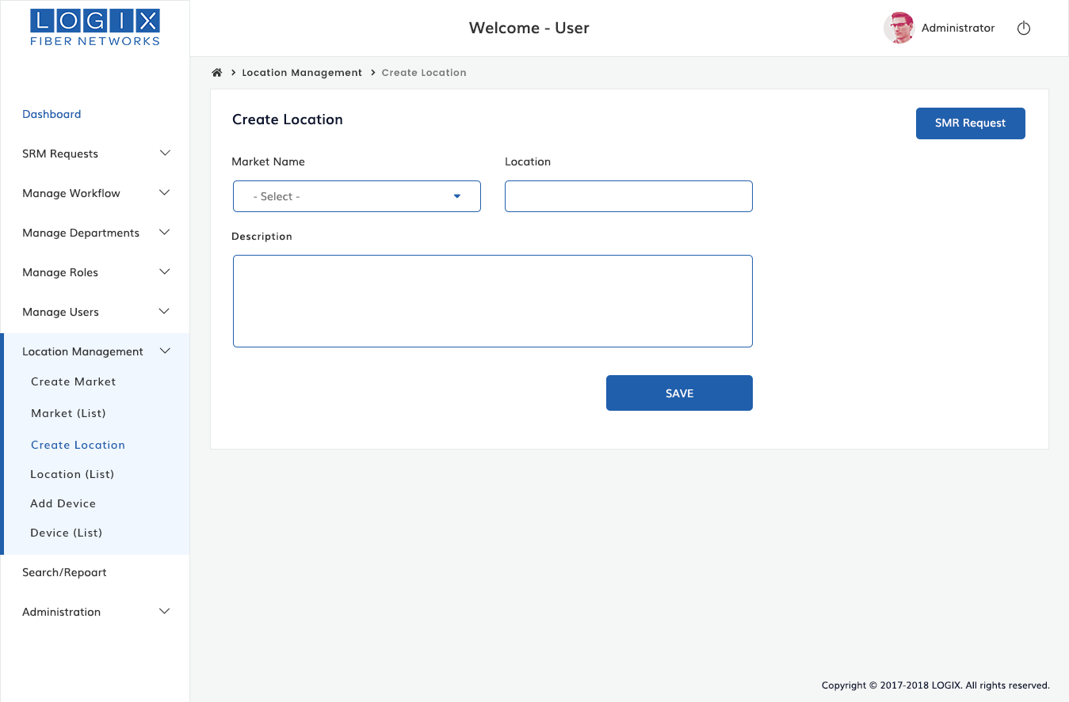

2.8.4 Locations (List)
List of locations shows as follows,
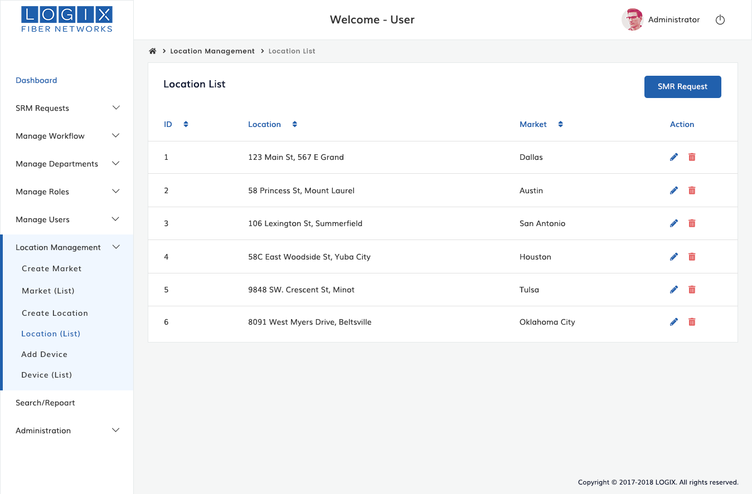

2.8.5 Add Device
Devices used to setup the most common type of devices used by the public.Examples Network hub,Network switch,router.
Follow the instructions to add Device,
Device section contains the below fields,
- Market Name
- Location
- Device Name
- Description
Step | Action
1 | In Location Management menu from the dashboard Click Add device sub menu which present below
2 | Choose a market name from the Market name list
3 | To location field,choose a location from the list
4 | Enter the device name as per need
5 | Type the description of device and click save button

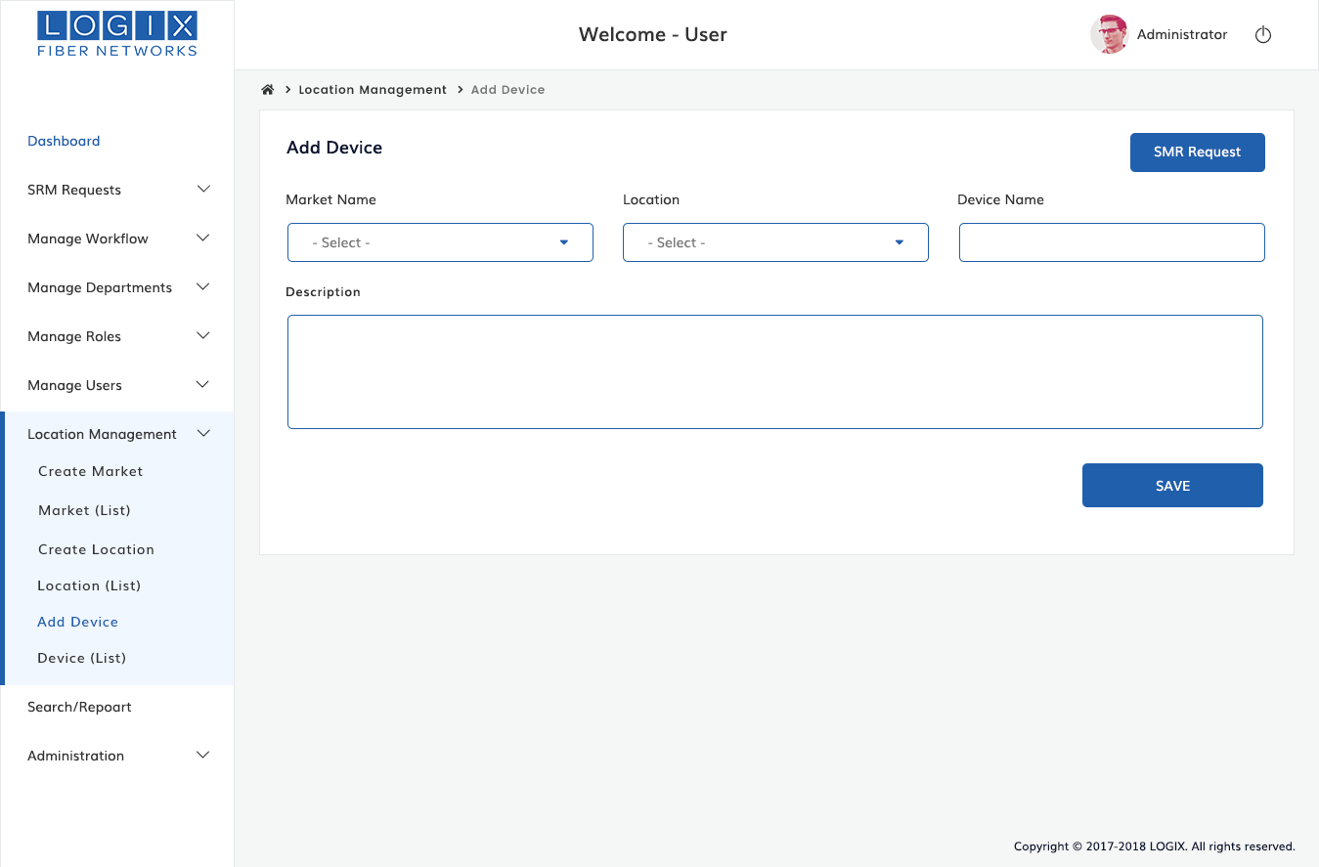

2.8.6 Device(List)
List of Devices as shown in the below,
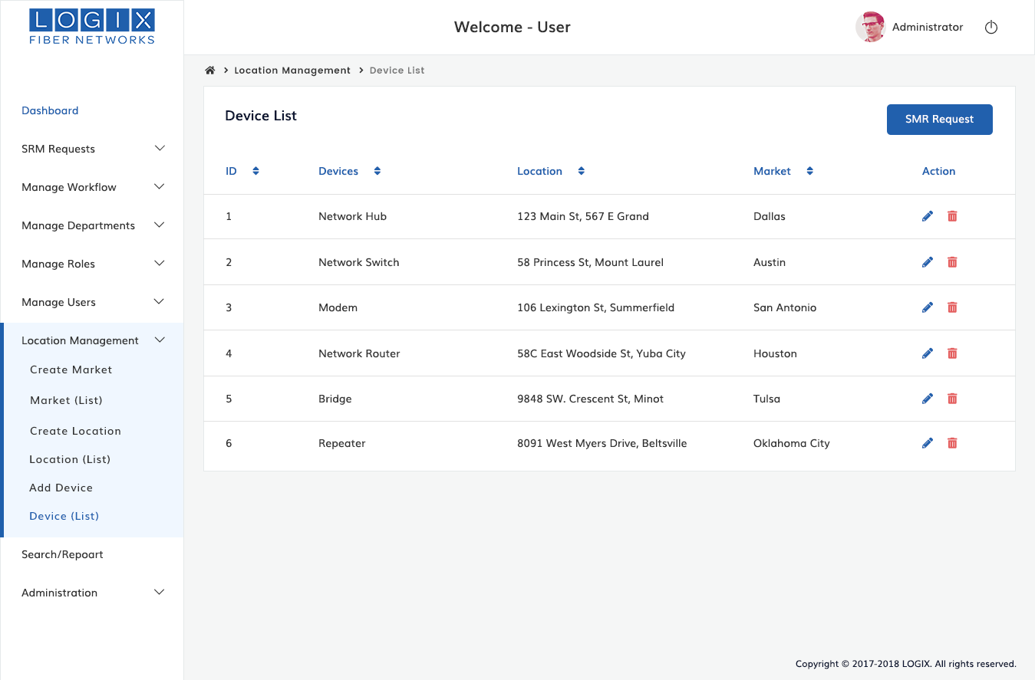

2.9 SEARCH/REPORT
This section offers you to find anything by name,location,device,submitter and date.
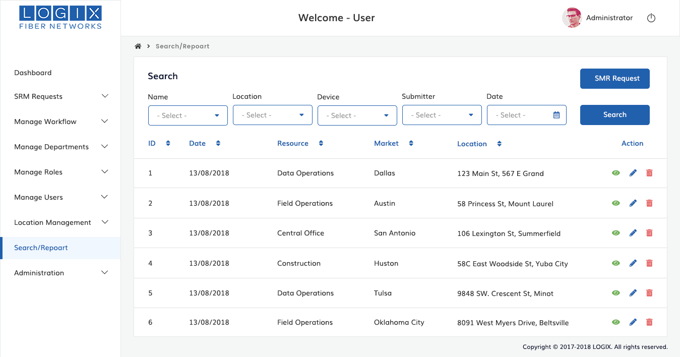

3.0 ADMINISTRATION
3.0.1 Submission Notification
This section specifies to save Notification message. The Submission Notification will receive to Originator via email.

Administration section contains the below fields,
- Subject
- Email Body
Step | Action
1 | Choose Administration Menu from the dashboard
2 | Enter the subject for message in the message field
3 | Type name and content of email to email body field
4 | Select originator to receive email notification
5 | Click and save button to save submission notification message

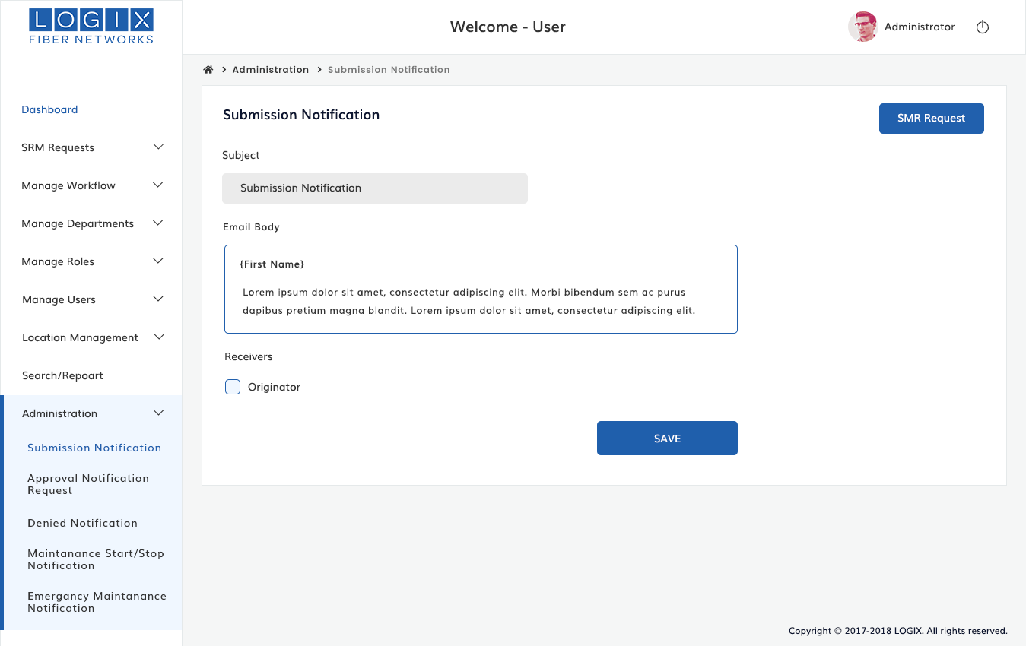

3.0.2 Approval Notification Request
Management approval email that lets them know that Request is ready for approval or rejection which includes a summary of the submission and a link for them, sending them back to the system to Approve/Deny the request directly and also provide comments.
Approval Notification consist of the below fields,
- Subject
- Email
- Recivers
Step | Action
1 | Choose Administration menu from the dashboard ->click Approval notification Request menu which present below
2 | Enter the name of subject in the Subject field
3 | Write down the name and content to Email body field
4 | Tick receivers from provided list and save it.Approval Notification request will receive to concerned receivers

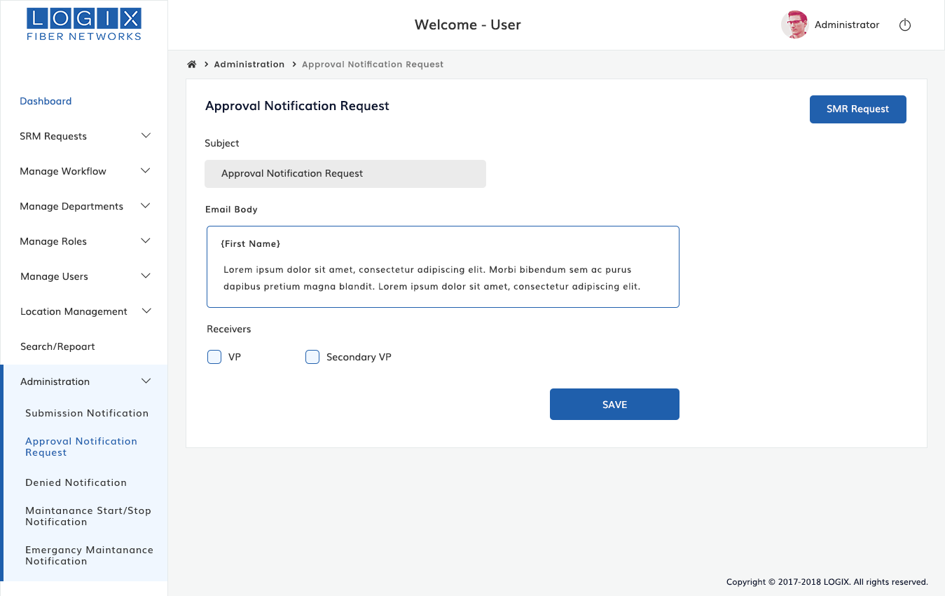

3.0.3 Denied Notification
Email sent to Originator where the request was denied, by which user and the reason.
Denied Notification Contains below fields,
- Subject
- Email
- Receivers
Step | Action
1 | Choose Administration menu from the dashboard ->click Denied Notification menu which present below
2 | Enter the name of subject in the Subject field
3 | Write down the name and content to Email body field
4 | Click receivers and save it.Notification request will receive to Originator

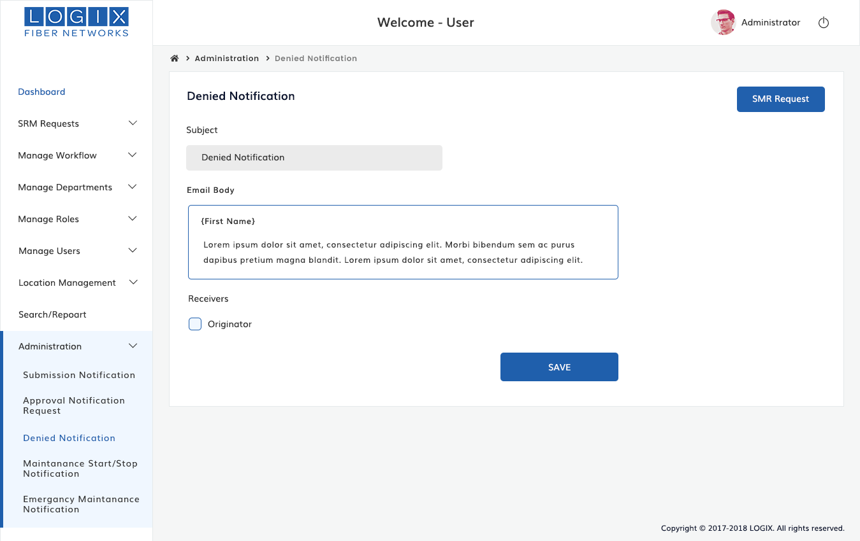

3.0.4 Maintenance Start / Stop Notification
Email to Originator who submitted the Request when the Maintenance starts and another when it stops. This also goes out to the Logix Maintenance distribution email address.
Maintenance Start / Stop Notification Contains below fields,
- Subject
- Email
- Receivers
Step | Action
1 | Choose Administration menu from the dashboard ->click Maintenance Start / Stop Notification menu which present below
2 | Enter the name of subject in the Subject field
3 | Write down the name and content to Email body field
4 | Tick receivers from provided list and save it.Notification request will receive through email to Originator

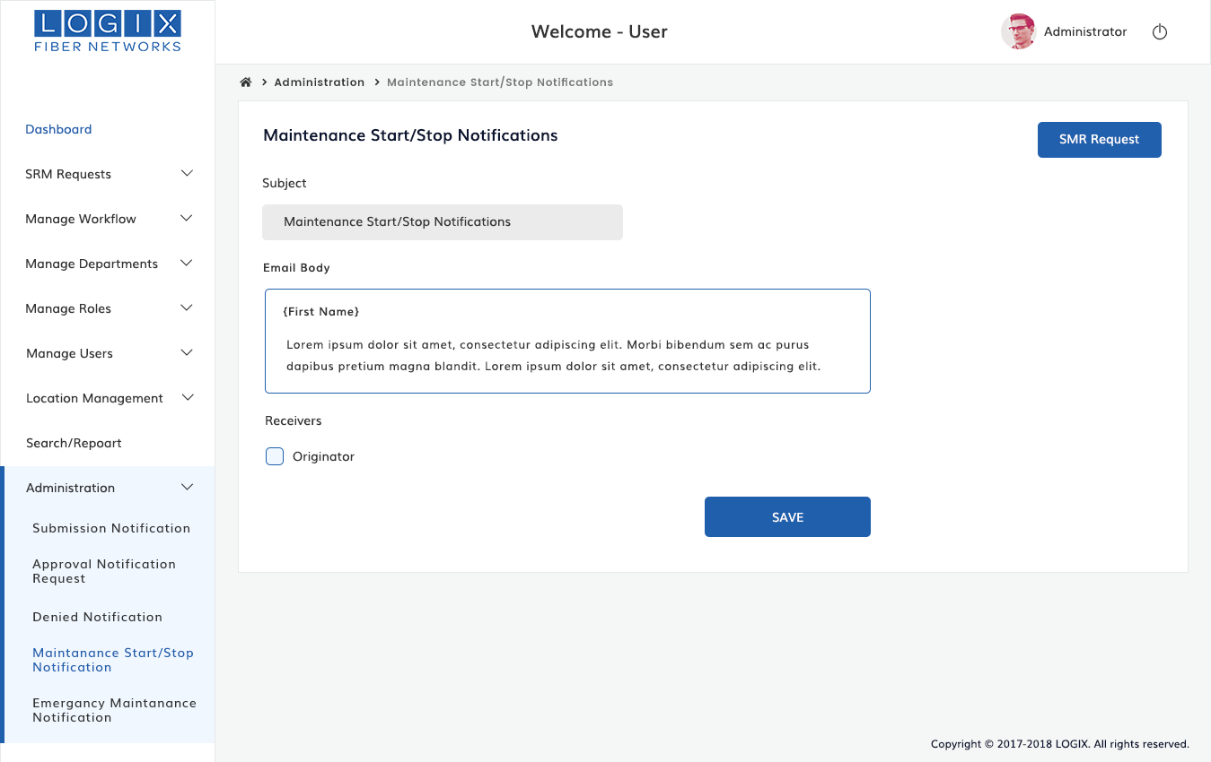

3.0.5 Emergency Maintenance Notification
Email to all associated parties that an Emergency notification has been submitted and needs approval.
Emergency Maintenance Notification Contains below fields,
- Subject
- Email
- Receivers
Step | Action
1 | Choose Administration menu from the dashboard ->click Emergency Maintenance Notification menu which present below
2 | Enter the name of subject in the Subject field
3 | Write down the name and content to Email body field
4 | Tick receivers from provided list and save it.Notification will receive to Originator via mail

